Assignment 4: Abstract Class Shape Hierarchy
Name: Enrique Ybarra
Course: Java Programming
Submission note: Source code is included below in text form. Replace each [SCREENSHOT] placeholder with your own IDE/output/Git captures before submitting.

This project defines an abstract Shape class with abstract methods surface_area() and volume(). Sphere, Cylinder, and Cone each extend Shape and provide their own implementations plus a toString() method. The ShapeArray driver stores one of each in a Shape[] array and prints them in a loop, demonstrating polymorphism.

1. Source Code (text)

Shape.java
// Shape.java
// Abstract base class for geometric shapes.
public abstract class Shape {
// Abstract method: each shape must provide its own surface area formula
public abstract double surface_area();
// Abstract method: each shape must provide its own volume formula
public abstract double volume();
}

Sphere.java
// Sphere.java
// A sphere, defined by its radius. Extends the abstract Shape class.
public class Sphere extends Shape {
private double radius;
// Parameterized constructor
public Sphere(double radius) {
this.radius = radius;
}
public double getRadius() {
return radius;
}
public void setRadius(double radius) {
this.radius = radius;
}
// Surface area of a sphere = 4 * pi * r^2
@Override
public double surface_area() {
return 4.0 * Math.PI * radius * radius;
}
// Volume of a sphere = (4/3) * pi * r^3
@Override
public double volume() {
return (4.0 / 3.0) * Math.PI * Math.pow(radius, 3);
}
// Prints the surface area and volume
@Override
public String toString() {
return String.format(
"Sphere (radius = %.2f): Surface Area = %.2f, Volume = %.2f",
radius, surface_area(), volume());
}
}

Cylinder.java
// Cylinder.java
// A cylinder, defined by its radius and height. Extends the abstract Shape class.
public class Cylinder extends Shape {
private double radius;
private double height;
// Parameterized constructor
public Cylinder(double radius, double height) {
this.radius = radius;
this.height = height;
}
public double getRadius() {
return radius;
}
public void setRadius(double radius) {
this.radius = radius;
}
public double getHeight() {
return height;
}
public void setHeight(double height) {
this.height = height;
}
// Surface area of a cylinder = 2 * pi * r * (r + h)
@Override
public double surface_area() {
return 2.0 * Math.PI * radius * (radius + height);
}
// Volume of a cylinder = pi * r^2 * h
@Override
public double volume() {
return Math.PI * radius * radius * height;
}
// Prints the surface area and volume
@Override
public String toString() {
return String.format(
"Cylinder (radius = %.2f, height = %.2f): Surface Area = %.2f, Volume = %.2f",
radius, height, surface_area(), volume());
}
}

Cone.java
// Cone.java
// A cone, defined by its radius and height. Extends the abstract Shape class.
public class Cone extends Shape {
private double radius;
private double height;
// Parameterized constructor
public Cone(double radius, double height) {
this.radius = radius;
this.height = height;
}
public double getRadius() {
return radius;
}
public void setRadius(double radius) {
this.radius = radius;
}
public double getHeight() {
return height;
}
public void setHeight(double height) {
this.height = height;
}
// Slant height = sqrt(r^2 + h^2), used in the surface area formula
private double slantHeight() {
return Math.sqrt(radius * radius + height * height);
}
// Surface area of a cone = pi * r * (r + slant height)
@Override
public double surface_area() {
return Math.PI * radius * (radius + slantHeight());
}
// Volume of a cone = (1/3) * pi * r^2 * h
@Override
public double volume() {
return (1.0 / 3.0) * Math.PI * radius * radius * height;
}
// Prints the surface area and volume
@Override
public String toString() {
return String.format(
"Cone (radius = %.2f, height = %.2f): Surface Area = %.2f, Volume = %.2f",
radius, height, surface_area(), volume());
}
}

ShapeArray.java
// ShapeArray.java
// Driver class. Creates one Sphere, one Cylinder, and one Cone, stores them
// in an array of Shape, and prints each using its toString() method.
public class ShapeArray {
public static void main(String[] args) {
// 1-3. Instantiate one of each shape
Sphere sphere = new Sphere(5.0);
Cylinder cylinder = new Cylinder(3.0, 7.0);
Cone cone = new Cone(4.0, 9.0);
// 4. Store the instances in an array typed as the superclass Shape.
// This works because of polymorphism: a Sphere, Cylinder, and Cone
// are all Shapes.
Shape[] shapeArray = { sphere, cylinder, cone };
// 5. Loop through the array and print each object's data. Java calls
// the correct overridden toString() for each concrete type at
// runtime (dynamic dispatch).
System.out.println("===== Shape Array Contents =====");
for (Shape shape : shapeArray) {
System.out.println(shape.toString());
}
}
}

2. Expected Program Output (verified)
===== Shape Array Contents =====
Sphere (radius = 5.00): Surface Area = 314.16, Volume = 523.60
Cylinder (radius = 3.00, height = 7.00): Surface Area = 188.50, Volume = 197.92
Cone (radius = 4.00, height = 9.00): Surface Area = 174.03, Volume = 150.80

3. IDE Screenshot (source + output)
[ SCREENSHOT: Full Eclipse window showing the source code and the Console output ]

4. Additional Test-Case Output Screenshots
Run again with different radius/height values (e.g. Sphere r=2, Cylinder r=5 h=10, Cone r=6 h=8) and capture the console output.
[ SCREENSHOT: Console output for a second set of test values ]

5. UML Diagram
UML class diagram showing the abstract Shape superclass, the three concrete subclasses (Sphere, Cylinder, Cone) with inheritance (extends) relationships, and the ShapeArray driver that uses them.
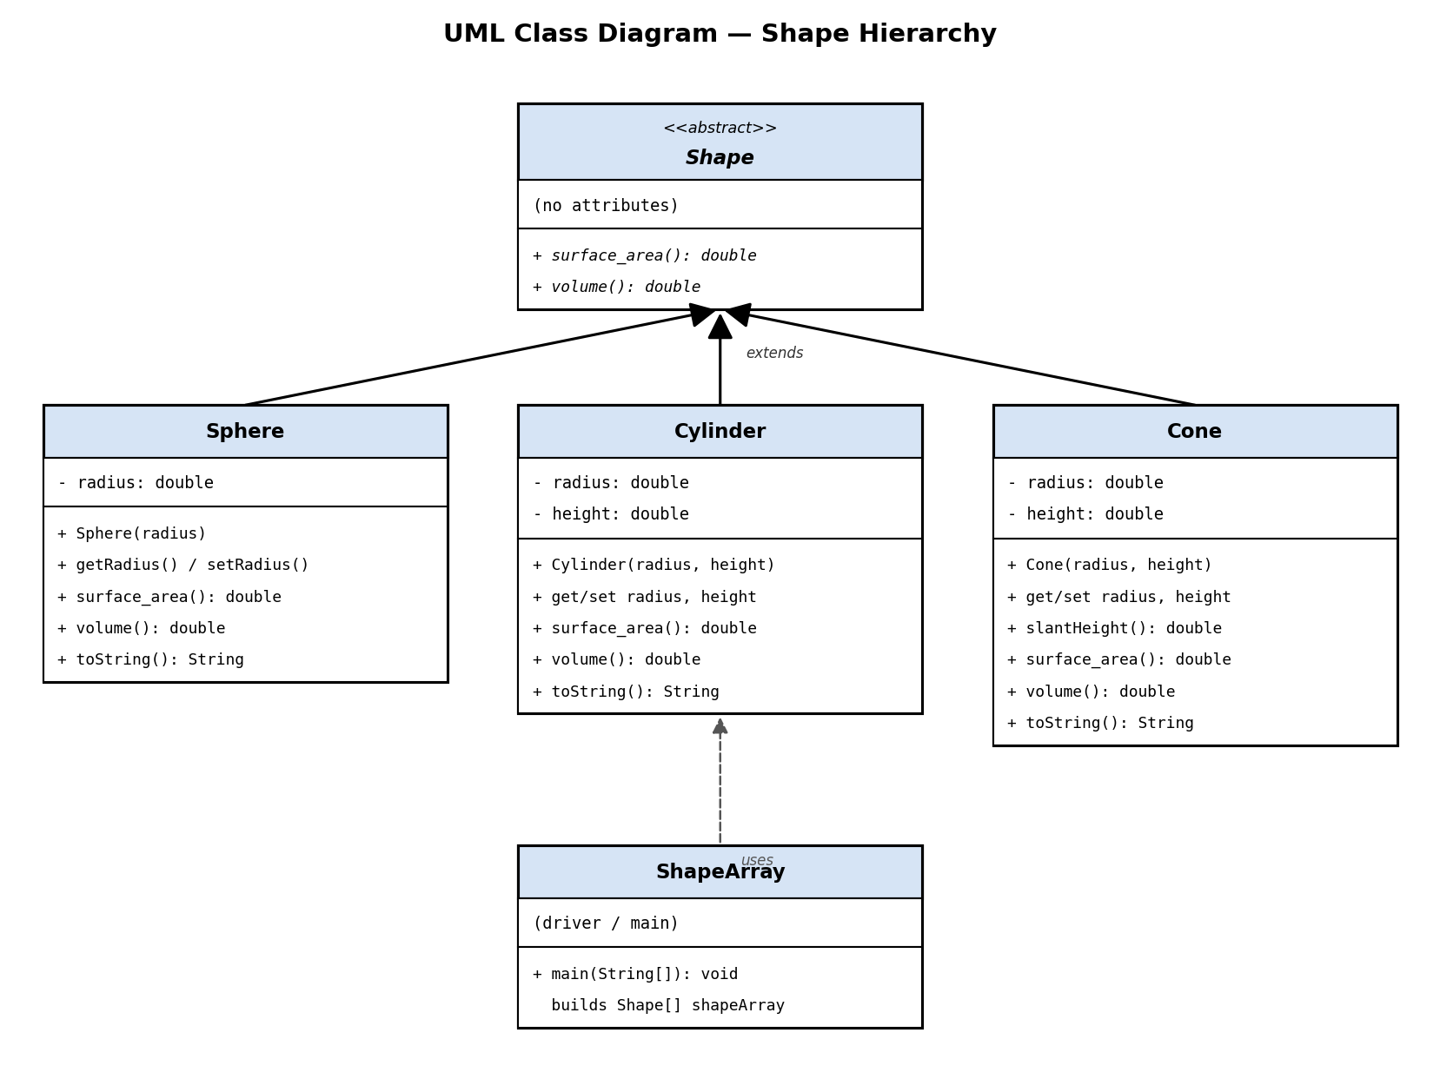

6. Version Control / Git Repository
[ SCREENSHOT: Your Git repository (commit history / GitHub repo), or paste the repo link here ]

